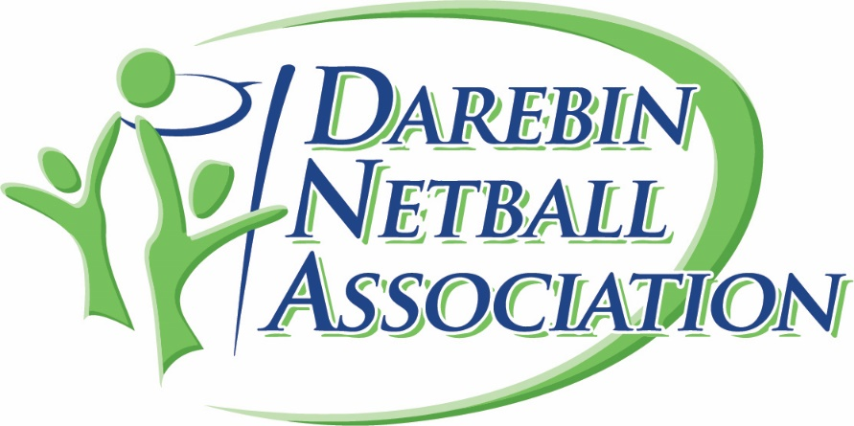

**Position Title:** HEAD COACH

**Reports to:** Darebin Committee

**Reported to by**: Rep Coaches

**Employment Status**: Volunteer

**Time Commitment:** 5-10 hours per week

**Commitment to Child Safety Standards**

Safety We require all applicants to undergo background checks and screening prior to or during any appointment. Netball’s Commitment Statement to Safeguarding Children and Young People and other important information can be found at <https://vic.netball.com.au/child-safety-netball>

At Darebin netball association, we embrace diversity in gender, age, ethnicity, disability, religion and sexual orientation. We are committed to providing a safe environment for children across Netball. Darebin netball association is committed to Safeguarding Children & Young People Every person in the netball community has a responsibility to understand their role in ensuring the safety and wellbeing of all children and young people in our care. Darebin netball association is committed to promoting and protecting the rights of children and preventing abuse from occurring by fostering a culture where children feel safe and empowered. We also seek to ensure the cultural safety of First Nations children, children from culturally and/or linguistically diverse backgrounds and children with a disability.

**Primary Purpose of Position**

* Responsible for the training, development and management of coaches and players. Help create a pathway for player to grow though the program

**Key Responsibilities**

* Conduct regular meetings with the coaches and report to the committee important information from meetings
* Help organise and inform coaches on coaching courses/clinics and accreditation
* Foster the growth and raise the standards of the coaches
* Ensure all coaches are recognised for their efforts per the associations
* Be the first point of contact for conflict resolution for players and coaches
* Can communicate effectively and has good interpersonal skills
* Positive and enthusiastic
* Well organised and able to work in an orderly manner
* Be able to relate to a diverse group of individuals
* Can maintain confidentiality on relevant matters
* Has a good working knowledge of the Constitution, By-laws, Rules and Policies of the organisation
* IT Competency- familiar with basic operation systems including Netball Connect
* Ethical, honest and trustworthy
* Dedicated association person
* Hold a minimum of Development Coaching Accreditation

**Other Requirements**

* ·Working with Children Check