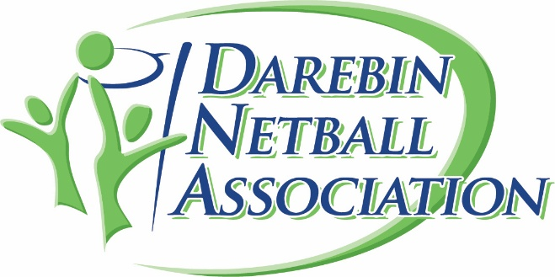

Darebin Netball Association - Child Safety Standards Policy
1. Purpose
This policy establishes the commitment of Darebin Netball Association (DNA) to providing a safe, supportive, and inclusive environment for all children and young people involved in netball. It sets out the standards, responsibilities, and practices that safeguard children from harm and promote their wellbeing.
2. Scope
This policy applies to:
- All players under 18 years of age.
- Coaches, umpires, officials, committee members, volunteers, parents/guardians, and spectators.
- All club-sanctioned activities, including training, matches, tournaments, travel, and social events.
3. Commitment to Child Safety
DNA is committed to:
- Promoting the rights of children and young people to feel safe, valued, and respected.
- Preventing abuse, neglect, and exploitation of children in netball.
- Responding promptly, fairly, and confidentially to all child safety concerns.
- Upholding relevant legislation, including child protection laws and Working with Children Check requirements.
4. Child Safety Standards
4.1 Safe Recruitment and Screening
- All adults in child-related roles must hold a valid Working with Children Check (or state equivalent).
- Recruitment processes include reference checks and clear role descriptions outlining child safety responsibilities.
4.2 Education and Training
- Coaches, officials, and volunteers receive induction and ongoing training on child safety, codes of conduct, and recognising/reporting abuse.
- Children and families are informed of their rights, reporting procedures, and support options.
4.3 Codes of Conduct
- All members must follow behaviour standards that prioritise child wellbeing, including:
  - Treating all children with respect and fairness.
  - Avoiding physical punishment, bullying, or humiliation.
  - Maintaining professional boundaries (e.g., no private messaging without parental awareness).
- Codes of Conduct are publicly available and signed by members in child-related roles.
4.4 Safe Netball Environment
- Facilities are assessed for safety and suitability.
- At least two adults are present at all training sessions and games.
- Clear procedures for travel, photography, social media use, and supervision are in place.
4.5 Reporting and Responding
- Concerns, complaints, or disclosures of harm are taken seriously, recorded, and escalated according to child protection law and organisational procedure.
- Reports may be made to:
  - DNA Child Safety Officer.
  - The Club Child Safety Officer.
  - Relevant child protection authorities or police.
- Whistleblowers are protected from victimisation.
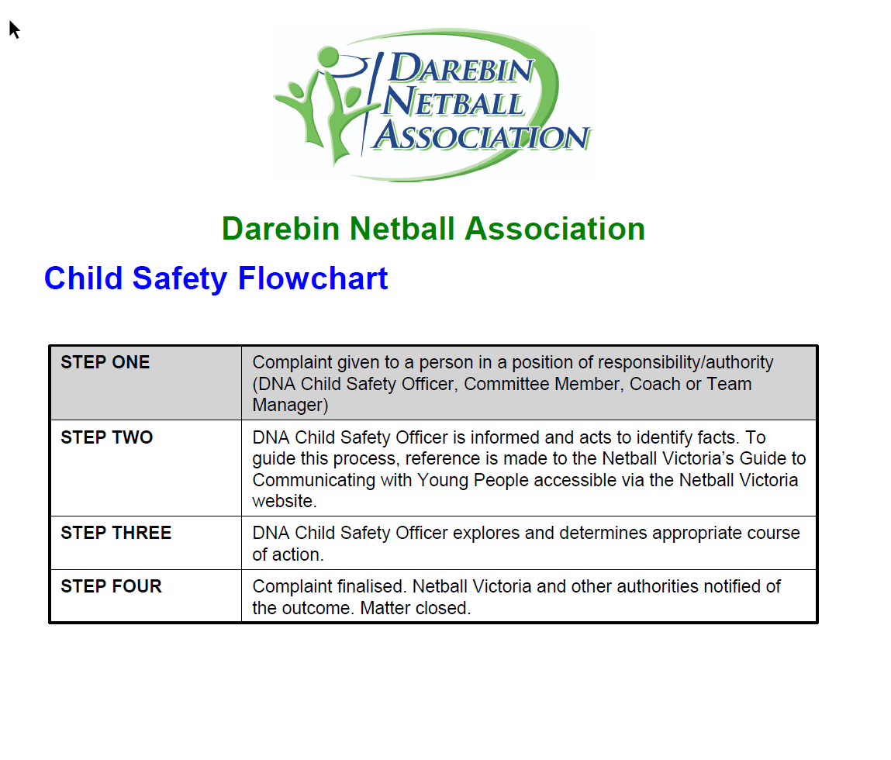
4.6 Participation and Empowerment
- Children are encouraged to express their views on matters affecting them.
- Feedback from young players is regularly sought to improve safety and wellbeing.
- Programs are inclusive of all children regardless of gender, culture, ability, or background.
5. Responsibilities
- Committee/Board: Ensure compliance with child safety laws and implementation of this policy.
- Child Safety Officer: Act as the first point of contact for concerns, manage reporting, and oversee policy adherence.
- Coaches/Officials/Volunteers: Uphold the standards in daily practice and model safe behaviours.
- Parents/Guardians: Support child safety measures and communicate concerns promptly.
6. Review
This policy will be reviewed every two years, or sooner if there are legislative changes, child safety incidents, or feedback requiring updates.
7. Related Documents
- Codes of Conduct (Players, Coaches, Officials, Parents) can be accessed here Code of Conduct - Netball VIC
- Complaints and Grievance Policy - Complaints Process | Darebin Netball
- Child Safety Policy Child-Safety-Policy.pdf
- Child Safety Code of Conduct Child-Safety-Code-of-Conduct.pdf

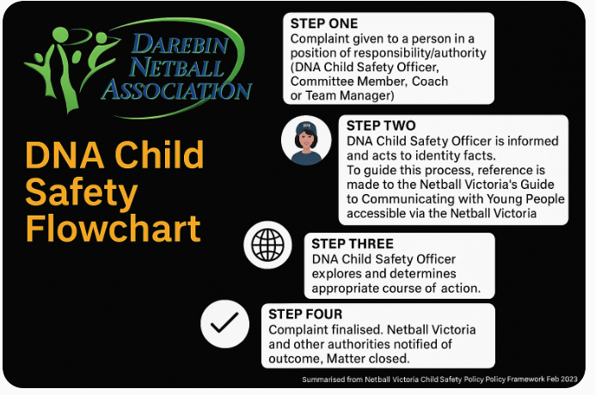

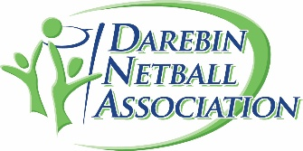 | Darebin netball association Commitment to Child Safety Feedback and Complaints

Our association is committed to child safety
We want children to be safe happy and empowered.
We have zero tolerance of child abuse, and all allegations and safety concerns will be treated very seriously and consistently with our robust policies and procedures.

If you have any concerns about child safety at our association, please let us know. Darebin Netball Association Welcomes your feedback.

We encourage you to tell us about your experience with our association. Your feedback helps us to improve our work and keep child and young people safe.

To find out more about our policy, or to provide feedback or make a complaint visit our website. Netball | Darebin Netball Association | Reservoir https://www.darebinnetball.com

If you believe a child is at immediate risk or abuse please phone 000.

